Lab Perceptron Pair-Group Project II
Eric Kvale, Cheik F

For problem set one we graphed the results from our Perceptron Class graphed in excel against the MIT Perceptron class implemented on the same data set graphed in Matplotlib.

Some of the graphs in Excel we were unable to represent correctly, so we included the graphs from the Matplotlib and MIT perceptron class (see refreneces) there as well.
Illustration 1: Petal Length x Petal Width 247, -23.9, -65.10
*** Replace with Updated Chart ***

Number of Errors: 3
Parameter Values: See Caption
Linear Equation: y = -0.44x + 3.688
Dataset Points = 100
Errors Percentage= 3%

Note: Pretty dang close to the MIT Perceptron class results
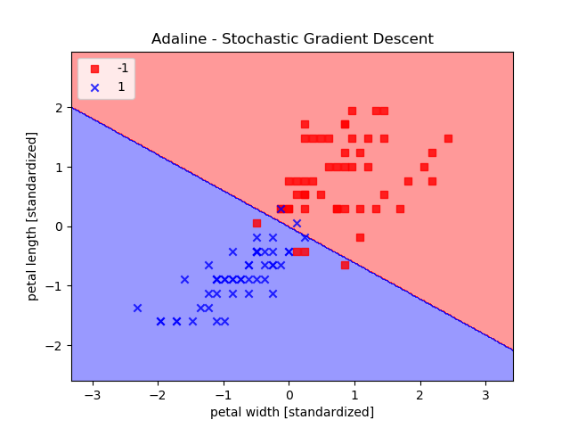
Illustration 2: Petal Length vs Petal Width 300 -78 -31

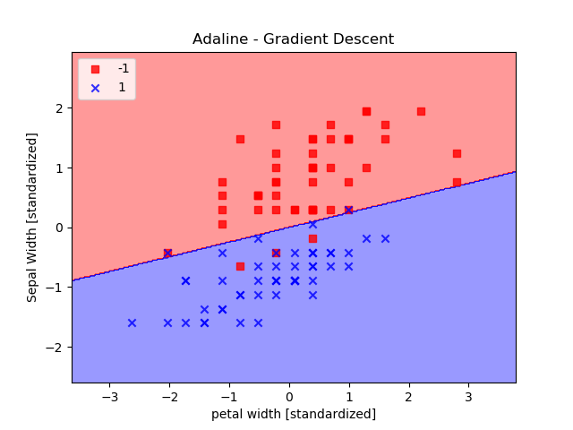
OUR RESULTS:
Number of Errors: 5
Parameter Values: 49, 13.4 -50.8
Linear Equation: y = 0.66x + 0.94
Dataset Points = 100
Errors Percentage= 5%
NOTE: Here are results were not quite as good.

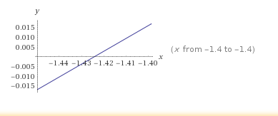
Illustration 3: SepalWidth x PetalWidth: 366 -50.9 -82.2
Illustration 4: Petal Length vs Petal Width 338 -40.50 -86.5

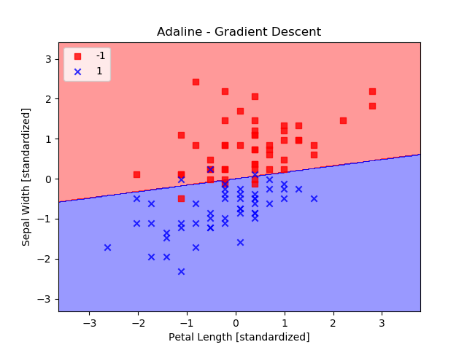
OUR RESULTS:
Number of Errors: 6
Paramater Values: 313 25.7 -81.8
Linear Equation: y = 0.16x + 0.00016
DataSet Points = 100
Errors Percentage= 6%
NOTE: Our perceptron didn’t find as good of a solution as possible. The MIT Perceptron found a better line.

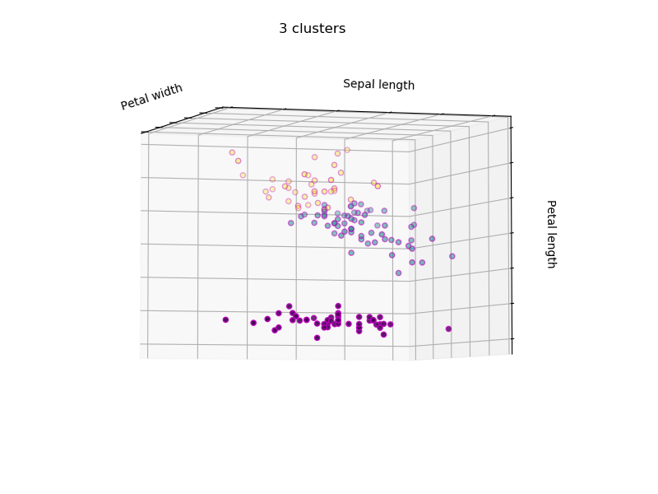
Illustration 5: All Three Species visualized as 3 Clusters with no Perceptron classifiers.
Features: Petal Length, Petal Width, Sepal Length

Problem 2:
It may be possible to draw a hyperplane in a three dimensional space, but it is not possible with this 2d excel chart as there are overlapping points in 2d space, and points that are not linearly separable.
Number of Errors: 4
Parameter-Values: 175, 43.8, -35, -94
No because, Excel doesn’t handle 3 dimensional graphics very well, and the data is not linearly separable.
Linear Equation: y = -46x + 3.91
Data Points = 100
% of Errors: 4%

Problem 3:

We chose the Wine Dataset as our first dataset to classify with the Perceptron class. For features we chose Hue and Ash.

OUR RESULTS:

Number of Errors: 8
Parameter-Values: -2597, 206.92, -70.06
Linear Equation: y = 33.79x + 218.954
Data Points = 131
% of Errors: 6%

**** INSERT YOUR GRAPH HERE WITH WEIGHTS IF YOU CAN GET WEIGHTS ****
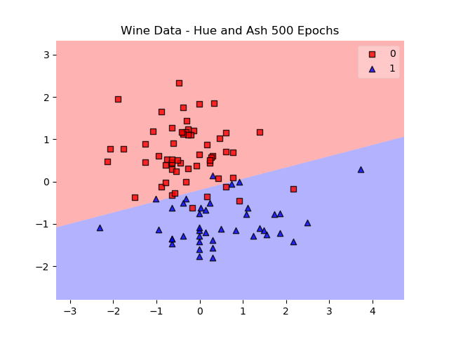

4.1
Yes they were, the attributes we chose did not have complete linear separability, but there was enough distinctions to plot effective separation.
4.2
No, because some attributes may be to clumped together, with little or no separation. A perceptron would not be able to draw a meaningful classifier.

4.3
33.79 Slope is positive
A line drawn vertically through the center of the cloud would be very determinative, however a line drawn horizontally, would do very little two classify.

Final Report:

The first data set we processed was the Iris Dataset with 2 species Virginica and Versicolor and processed several different feature sets. Petal Width, Petal Length, Sepal Width.

Our Perceptron had performance on par with the MIT class with the Petal Length x Petal Width classification, but performed noticeable worse with crowded classes. We faced challenges with graphing from excel.

All Data Sets were processed using our Perceptron Class. Results were cross-referenced with Sebastian Rascha’s Perceptron Class from the book Python Machine Learning (referenced as MIT Perceptron class throughout lab)

Sebastian Raschka, 2015 (http://sebastianraschka.com)
Python Machine Learning - Code Examples

https://github.com/rasbt/python-machine-learning-book/blob/master/LICENSE.txt
The Wine-Data set was analyzed with mlxtend Perceptron class.
https://rasbt.github.io/mlxtend/user_guide/classifier/Perceptron/

